# Test Activities and Test Roles

## 1-Test Activities

**# Source**: **Chatgpt (GPT-5-Standard) at [8/12/2025]**

**Test Activities** are the main steps in the **software testing process** — they describe *what testers do* from start to finish.

Here’s the standard sequence (from **ISTQB testing process**):

### 1-**Test Activities Types**

#### 1. Test Planning 📝

**# Source**: **Chatgpt (GPT-5-Standard) at [8/12/2025]**

* Define the **scope**, **objectives**, **strategy**, resources, schedule, and risks.
* Decide **what to test**, **how to test**, and **when to stop testing** (exit criteria).

#### 2. Test Monitoring and Control 📊

**# Source**: **Chatgpt (GPT-5-Standard) at [8/12/2025]**

* **Monitoring:** Track test progress (e.g., how many tests passed/failed).
* **Control:** Adjust the plan if things go off track (e.g., change priorities, add more testers).

#### 3. Test Analysis 🔍

**# Source**: **Chatgpt (GPT-5-Standard) at [8/12/2025]**

* Review requirements, design, and other documents to find **test conditions**.
* Example: From “Users must be able to reset password” → create test condition: *"Verify password reset process works via email link."*

#### 4. Test Design 🛠

**# Source**: **Chatgpt (GPT-5-Standard) at [8/12/2025]**

* Convert test conditions into **test cases**, **test data**, and **expected results**.
* Decide which tools/scripts you’ll use.

#### 5. Test Implementation ⚙

**# Source**: **Chatgpt (GPT-5-Standard) at [8/12/2025]**

* Prepare **test suites**, configure test environments, load test data.
* Link test cases to requirements.

#### 6. Test Execution ▶

**# Source**: **Chatgpt (GPT-5-Standard) at [8/12/2025]**

* Run the tests, compare actual vs. expected results.
* Report any **defects** found.

#### 7. Test Completion ✅

**# Source**: **Chatgpt (GPT-5-Standard) at [8/12/2025]**

* Check if exit criteria are met.
* Write test summary reports, archive test artifacts, and analyze lessons learned.

💡 **In short:**

Plan → Monitor/Control → Analyze → Design → Implement → Execute → Complete

### Example of Test Activities

**# Source**: **Chatgpt (GPT-5-Standard) at [8/12/2025]**

Alright — here’s an **example of Test Activities** mapped to a real project so it’s easier to imagine.

#### Scenario:

**# Source**: **Chatgpt (GPT-5-Standard) at [8/12/2025]**

You’re testing an **online food delivery app** like Talabat or Uber Eats.

#### 1. Test Planning 📝

**# Source**: **Chatgpt (GPT-5-Standard) at [8/12/2025]**

* Decide to test **user login, restaurant search, cart checkout**.
* Risk: Payment failures could impact revenue, so payment is high priority.
* Exit criteria: 100% of critical tests must pass, ≤ 2 minor UI bugs allowed.

#### 2. Test Monitoring & Control 📊

**# Source**: **Chatgpt (GPT-5-Standard) at [8/12/2025]**

* Daily track: “20% of test cases executed, 5 defects found, 2 fixed.”
* If login testing is delayed → shift one tester from search testing to login.

#### 3. Test Analysis 🔍

**# Source**: **Chatgpt (GPT-5-Standard) at [8/12/2025]**

* From requirement: “User can pay with credit card or cash.”
* Test conditions:  
  1. Payment via valid credit card succeeds
  2. Payment via expired card fails
  3. Payment via cash option succeeds

#### 4. Test Design 🛠

**# Source**: **Chatgpt (GPT-5-Standard) at [8/12/2025]**

* Test case example:  
   **ID:** PAY-01  
   **Step:** Select credit card → enter valid card → confirm payment  
   **Expected Result:** Payment success message shown

#### 5. Test Implementation ⚙

**# Source**: **Chatgpt (GPT-5-Standard) at [8/12/2025]**

* Upload test cases into a tool like **Jira/Xray** or **TestRail**.
* Prepare test environment with **test payment gateway** and sample restaurant data.

#### 6. Test Execution ▶

**# Source**: **Chatgpt (GPT-5-Standard) at [8/12/2025]**

* Run test case PAY-01 → Actual: Payment success. **PASS**
* Run PAY-02 (expired card) → Actual: App crashes. **FAIL → Defect logged**

#### 7. Test Completion ✅

**# Source**: **Chatgpt (GPT-5-Standard) at [8/12/2025]**

* Exit criteria met: All critical tests passed after fixes.
* Defect summary: 12 bugs found, 12 fixed.
* Lessons learned: Need earlier environment setup to avoid delays.

This way, you can see the **testing process is not just clicking buttons** — it’s planned, tracked, and reported.

#### Summary

**# Source**: **Chatgpt (GPT-5-Standard) at [8/12/2025]**

(Based on standards like **ISTQB**)

1. **Test Planning** 🗓️  
   * Define the scope, objectives, approach, resources, schedule, and risks of testing.
   * Example: Decide what features to test, who will test them, and what tools to use.
2. **Test Analysis** 🔍  
   * Study requirements and identify **what** needs to be tested.
   * Example: From a login requirement, identify that username, password, and error handling need tests.
3. **Test Design** ✏️  
   * Create detailed **test cases** and **test data** to cover identified requirements.
   * Example: Write a test case for “Login with incorrect password shows error message.”
4. **Test Implementation** ⚙️  
   * Prepare test environment, finalize test cases, and set up automation if needed.
   * Example: Configure staging server and load test scripts into a testing tool.
5. **Test Execution** ▶️  
   * Run the tests and record the results (pass/fail).
   * Example: Execute login test cases and note that 3 passed, 1 failed.
6. **Test Completion & Closure** 📄  
   * Summarize results, evaluate exit criteria, document lessons learned, and archive testware.
   * Example: Write a final test report and mark testing as complete.

## 2-Test Roles

**# Source**: **Chatgpt (GPT-5-Standard) at [8/12/2025]**

**Test Roles** are the different responsibilities and positions people take on within the **software testing process** to make sure testing is planned, executed, and reported effectively.

It’s basically **“who does what”** in testing.

### Common Test Roles

**# Source**: **Chatgpt (GPT-5-Standard) at [8/12/2025]**

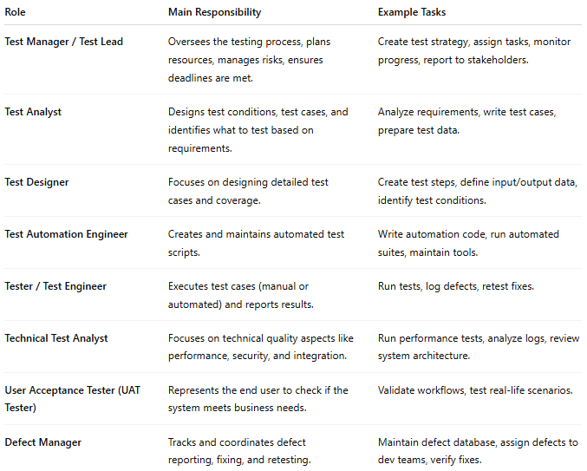

| **Role** | **Main Responsibility** | **Example Tasks** |
| --- | --- | --- |
| **Test Manager / Test Lead** | Oversees the testing process, plans resources, manages risks, ensures deadlines are met. | Create test strategy, assign tasks, monitor progress, report to stakeholders. |
| **Test Analyst** | Designs test conditions, test cases, and identifies what to test based on requirements. | Analyze requirements, write test cases, prepare test data. |
| **Test Designer** | Focuses on designing detailed test cases and coverage. | Create test steps, define input/output data, identify test conditions. |
| **Test Automation Engineer** | Creates and maintains automated test scripts. | Write automation code, run automated suites, maintain tools. |
| **Tester / Test Engineer** | Executes test cases (manual or automated) and reports results. | Run tests, log defects, retest fixes. |
| **Technical Test Analyst** | Focuses on technical quality aspects like performance, security, and integration. | Run performance tests, analyze logs, review system architecture. |
| **User Acceptance Tester (UAT Tester)** | Represents the end user to check if the system meets business needs. | Validate workflows, test real-life scenarios. |
| **Defect Manager** | Tracks and coordinates defect reporting, fixing, and retesting. | Maintain defect database, assign defects to dev teams, verify fixes. |

### **Example**

**# Source**: **Chatgpt (GPT-5-Standard) at [8/12/2025]**

Imagine you’re testing an e-commerce site:

* **Test Manager**: Decides testing scope and resources.
* **Test Analyst**: Reads the requirements and says “We must test checkout, login, and search.”
* **Tester**: Executes those tests.
* **Automation Engineer**: Writes Selenium scripts to test checkout automatically.
* **UAT Tester**: Pretends to be a customer and tries buying something.